**Fish grow faster to a smaller size under intense exploitation and warming waters in China with mixed impacts on fishery productivity**

Cody Szuwalski1, Alice Lee2, Lee Qi3, others to come

1Alaska Fisheries Science Center, National Oceanic and Atmospheric Administration, Seattle, WA, 98105

2 U.S. Fish and Wildlife Service, Colorado,

3University of Washington, School of Aquatic and Fishery Sciences, Seattle, WA

China’s marine populations have experienced intense fishing pressure and exist in seas for which temperatures have risen over the past 50 years. We catalogue changes in life history based on ~1500 records from the Chinese scientific literature over this period. Increasing growth rates, smaller maximum sizes, and increases in natural mortality have been documented in important commercial species. These changes have resulted different directional changes in productivity by stock as seen through yield per recruit analyses. Chinese fisheries management reform is underway, but we demonstrate the outcomes of reform could depend upon whether or not life history changes are plastic or selection-based and how life history may change with changes in fishing pressure and climate.

**Main text**

China’s large marine ecosystems are possibly the most intensely exploited seas on the planet. China has the most powerful fishing fleet in the world (200,000 vessels at XX kilowatts in 2016; Watson et al., 2019) and produces 15% of the world’s wild-captured seafood (13 million tons domestically in 2016; REF). China’s fleets fish primarily with indiscriminate gear like trawl and gill nets and do not discard undersized fish as a result of domestic markets for all species and sizes of fish (REF). Currently, fisheries are managed with closed seasons, gear restrictions, and limits on fleet size and power. Changes in ecosystem composition have followed this intense exploitation in many places, with communities shifting from demersal, higher value fish species to pelagic species (REF). With these changes in exploitation and community composition, it is possible that life history characteristics have also changed over time.

The life history of a species includes processes such as somatic growth, natural mortality, maturity schedules, and reproduction. These processes determine how intensely a population can be harvested and models based on these processes form the foundation of modern fishery science (REF). However, many of the models used to manage exploited fish stocks assume that these processes are constant over time (REF). Violation of these assumptions can result in flawed management advice and projections of yields (REF). There are many ways that the assumption of constant life history can be violated in reality. For example, shifting temperatures can change growth rates in marine species (REFs), density-related influences can change natural mortality (REF), changes in food availability can change the weight at length relationship (REF), and changes in predation can influence natural mortality and recruitment (REF). Exploitation can also change the characteristics of a population (REF).

China’s fishery structure. Trophic cascades (Szuwalski et al., 2017) and recruitment driven dynamics (Liang et al., 2023)

China’s fisheries appear to be recruitment driven, which means THIS (Liang et al., 2023). When a fishery is recruitment driven, yield per recruit analyses area useful in understanding the productivity of a stock. Yield per recruit analyses uses information about weight-at-age, selectivity-at-age, and natural mortality to project the catch that could be expected from a single fish over a range of exploitation rates (see methods).

Given the potential for intense exploitation and warming oceans to influence the life history of exploited species, we surveyed the Chinese and English language literature for studies reporting estimates of growth, natural mortality, and weight at age. We then characterized the temporal trends in life history processes of commercial species using generalized additive models (GAMs). Next, we used the trends observed in life history processes to calculate changes in yield per recruit over time for species with sufficient data. Finally, we developed models for the changes in life history processes based on fishing mortality and sea surface temperature to evaluate the potential impacts of management reform on fishery productivity.

**Methods**

*Life history estimates collection*

What did we search for in Chinese literature?

*Sea surface temperature data*

<https://www.metoffice.gov.uk/hadobs/hadisst/data/download.html>

*Yield per recruit and life history parameter trends*

We fit generalized additive models (GAMs; Wood, 2011) to the parameter estimates from the literature search with year as a smooth covariate to estimate a time trend in a parameter. These time trends were then used in calculations of yield per recruit to quantify changes in fisheries productivity over time. Yield per recruit analyses track the proportion of the weight of a single recruit remaining at equilibrium by age given an input natural mortality, fishery selectivity, weight at age (which captures somatic growth), and fishing mortality.

The steps in this portion of the analysis were:

1. Initialize the analysis with a single recruit at age 1 with the rest of the age composition filled in by decrementing that recruit by natural mortality for the appropriate number of years (equations 1-2)
2. Specify the processes impacting the population dynamics of the stock in question (e.g. natural mortality, fishery selectivity, and growth (as seen through weight at age) based on the time trends for a given year identified in the database with GAMs
3. Project forward under a fixed fishing mortality until YPR reaches equilibrium (equations 3-4)
4. Record the yield per recruit as the sum of equation 5 at equilibrium
5. Repeat for a range of fishing mortality values to fill out the YPR curve

|  |  |
| --- | --- |
|  | Eq 1 |
|  | Eq 2 |
|  | Eq 3 |
|  | Eq 4 |
|  | Eq 5 |

When are yield per recruit calculations appropriate/useful?

What does the literature say about the prevalence of these situations?

*F vs. SST vs. Life history and fisheries reform*

We fit two-dimensional generalized additive models that predict a given life history parameter for a given species based on the interaction between estimated fishing mortality and sea surface temperature of the form:

These GAMs produced an estimated surface of life history parameters by species given an SST and a fishing mortality. Given the observed relationships between life history parameters, fishing mortality, and sea surface temperature, it is natural to ask what impact fisheries reform might have on the productivity of these stocks. Changes in life history could plastic responses or selected responses. If the changes were a plastic, phenotypic response, it is still possible that life history could change back to previous values with changes in exploitation, if exploitation was the key driver of the change. A selected response represents the possibility that the changes in life history are permanent and a result of population-level selection in which the genes related to later maturity, larger body sizes, and slower growth rates have been removed from the population. If life history changes were selected for, the new productivities cannot be reversed. But, if life history changes were plastic, the surface of each parameter value in F/SST parameter space estimated above can be used to calculate yield per recruit in the same manner described previously. To do this, we predicted the parameter values related to growth and mortality required for the YPR calculations by inputting the current SST and a fishing mortality that was 50% of previous highest estimate. Then the predicted parameter values were used to calculate YPR curves.

**Results**

We identified ~1500 records of estimates of parameters associated with life history processes of 89 species from the Chinese language scientific literature to quantify changes in these processes (see SI). Of these records, sufficient temporal coverage existed for only four species to characterize change in life history over time: *Trichiurus lepturus, Scomber japonicus, Larmichthys polyactis,* and *Decapterus maraudsi.* These species represent XX% of the total catch reported by China in 2016 (figure 1). Generally, these species grew to a smaller maximum size (Linf) more quickly (k) over the last 50 years (figure 2). Estimated natural mortality and fishing mortality generally increased over this time, but changes in the relationship between weight and length were less uniform (Figure 2).

Small yellow croaker, largehead hairtail, and chub mackerel had the requisite information to calculate yield-per-recruit (YPR) over time. YPR for small yellow croaker changed the least over the study period, with YPR in 2014 only ~20% higher than that in 1960 (Figure 3). Largehead hairtail changed the most, with YPR increasing nearly 75% since 1960. Chub mackerel YPR decreased nearly 75% since 1960 (Figure 3).

The two-dimensional GAMs predicting parameter values using sea surface temperature and fishing mortality explained a large amount of the deviance (XX-XX%). Different relationships appear to exist between life history parameters and fishing pressure and sea surface temperature for these three species (Figure 4). Life history parameters for chub mackerel correlated most strongly with fishing mortality, but interactions between fishing mortality and SST can be seen for life history parameters for largehead hairtail and small yellow croaker. ADD MORE.

Describe F_mort vs SST

Reducing fishing mortality at same temp:

Natural mortality:

hairtail: increases

syc: decreases

mack: increases, temp not important

Growth k:

hairtail: decrases faster than if colder

sych: decreases more quickly than if colder

mack: decreases, temp not important

Growth Linf:

hairtail: decreases faster than if colder

sych: decreases slower than if colder

mack: decreases, temp not important

For chub mackerel, decreases in fishing pressure may produce beneficial changes in productivity.

For hairtail and small yellow croaker, decreases in fishing pressure could reverse beneficial changes in productivity.

**What happens to yield per recruit when you decrease F, but keep SST the same? What year is this most similar to in figure 3?**

**Discussion**

Our analysis is a conceptual exercise in identifying the impacts of changes in life history on fisheries productivity and potential impacts of fisheries reform in changing systems. We outlined a methodology for identifying trends in life history parameters and incorporating those trends into yield per recruit analyses to quantify how changes in life history could change fisheries yield. Then, by relating the changes in parameters to changes in exploitation and sea surface temperature, we provide a way to evaluate the potential impacts of fisheries reform on productivity. We found mixed impacts of life history changes on fisheries productivity and mixed impacts of potential fisheries reform. Studies in the scientific literature corroborate some of the conclusions we draw from this analysis, but there are also strong caveats that should encourage caution when interpreting our results.

First the corroboration.

Other life history changes in China.

Life history changes globally.

Yield per recruit changes represent tradeoffs between mortality and growth. Talk about impacts of changes in M over time.

Then the (many) caveats.

Weaknesses of life history ‘data’ collected (methodology sometimes suspect)

Periods of time for which no data exist and strong interpolation/poor deviance explained

Few species with good enough data to do something useful

No uncertainty reported usually.

Comparing interpolated trends of life history to interpolated trends in F is somewhat naughty.

Extrapolation beyond well-explored parameter space by GAMs can be a bad idea.

China’s 13th 5-year plan emphasized improving the ecological condition of their oceans and strides have been made towards accomplishing this goal (CCCPC, 2016). For example, pilot projects aimed at improving fisheries management are underway in coastal provinces and the length of the closed season was extended a month in 2017 to approximately 4 months (*MOA, 2017*). China’s goals for 2020 are to decrease catches from wild capture fisheries to 10 million tons, eliminate 40% of fisheries subsidies, and reduce the fishing fleet by 20,000 vessels and 1.5 million kilowatts (*2*). The way in which planned decreases in catch and fleet capacity are undertaken (in addition to reducing subsidies) will have large implications for ecological and economic outcomes.

None of these analyses consider what impact reversing the trophic cascades would have, but other analyses suggest much lower catches.

What does the literature say about the potential for these sorts of traits to be plastic vs. selection-based? Which of these scenarios are most likely?

Dangers of using life history invariants for stocks that are undergoing changes in life history for natural mortality.

Ultimately, we don’t want to rely on decision analysis/risk analysis, we want to know what is going to happen. Experimental management might be a useful way of understanding the impact of different management measure and China has a pilot project system already established that would facilitate this. (Walters, Martel, Sainsbury) However, pilot projects can also be misleading when there are ecosystem level effects of reform efforts (half written paper that needs to be published…).

Make this relevant to the rest of marine fisheries.

Much of fisheries management is in more lightly modified ecosystems.

Understanding the outcomes of reform in highly modified ecosystems may be a different question than the outcomes of more lightly modified ecosystems

**References**

Liang, C., Pauly, D., Christensen, V., Xian, W., Walters, C. 2023. Recruitment-driven fish production in two regions where fish biomass has drastically declined. ICES J Mar Sci. doi.org/10.1093/icesjms/fsad029

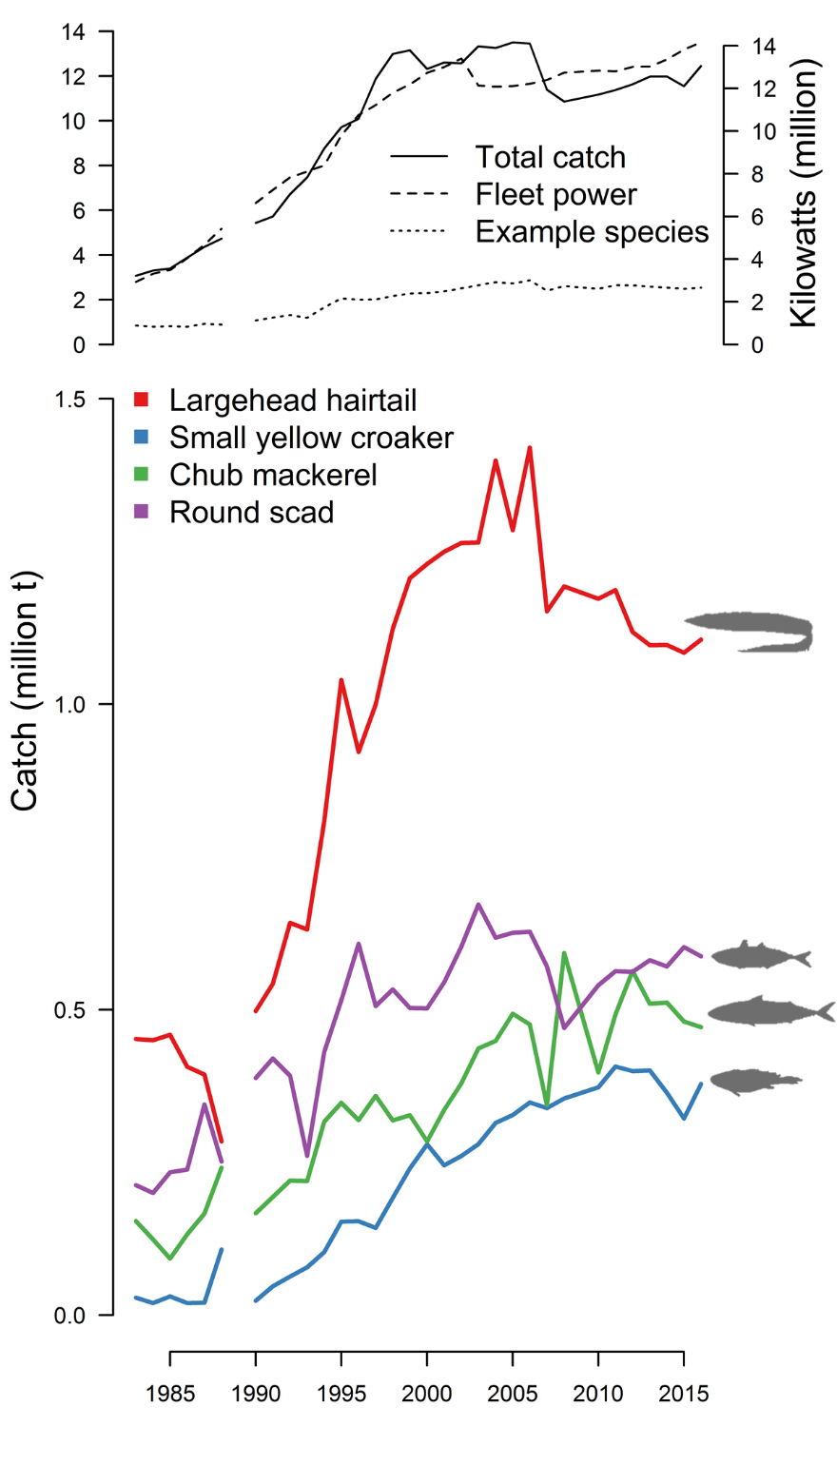

Figure 1. Total Chinese fisheries catch, fishing effort as seen through fleet power, and fraction the study species contribute to total (top). Domestic catches for three major commercial species (bottom).

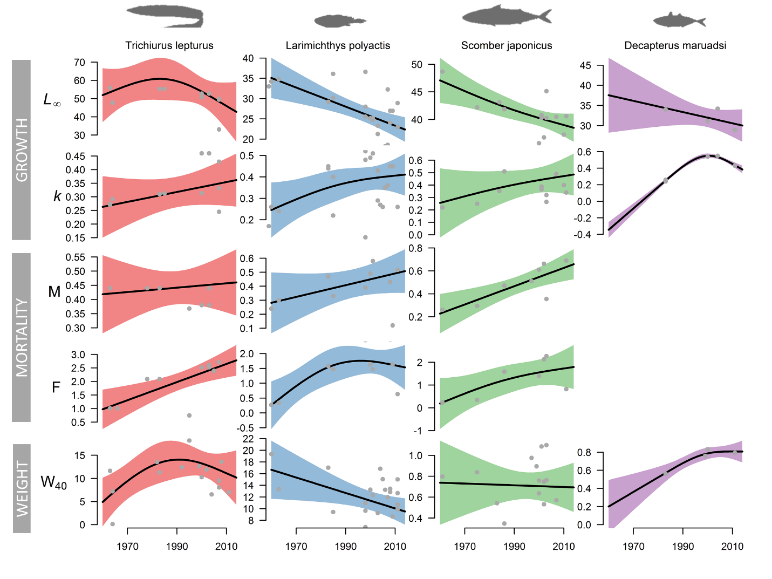

Figure 2. Trends in life history parameters for selected commercially important species over time in China.

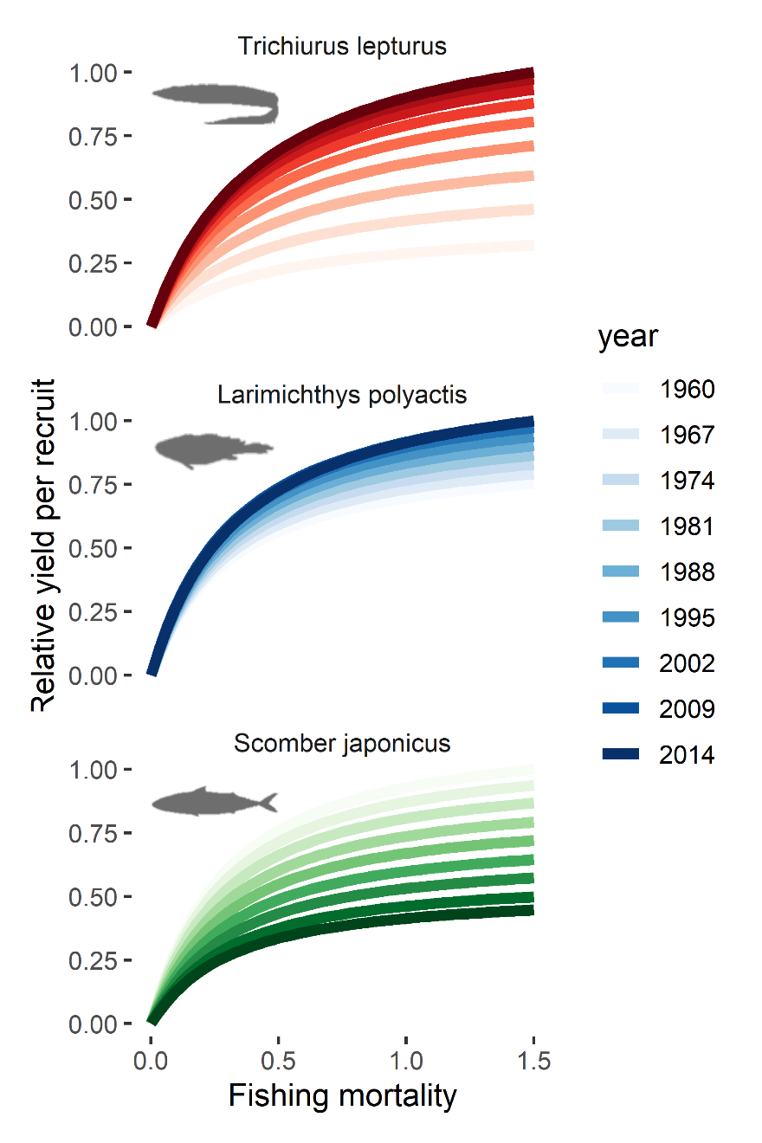

Figure 3. Changes in yield per recruit by species in China over the study period.

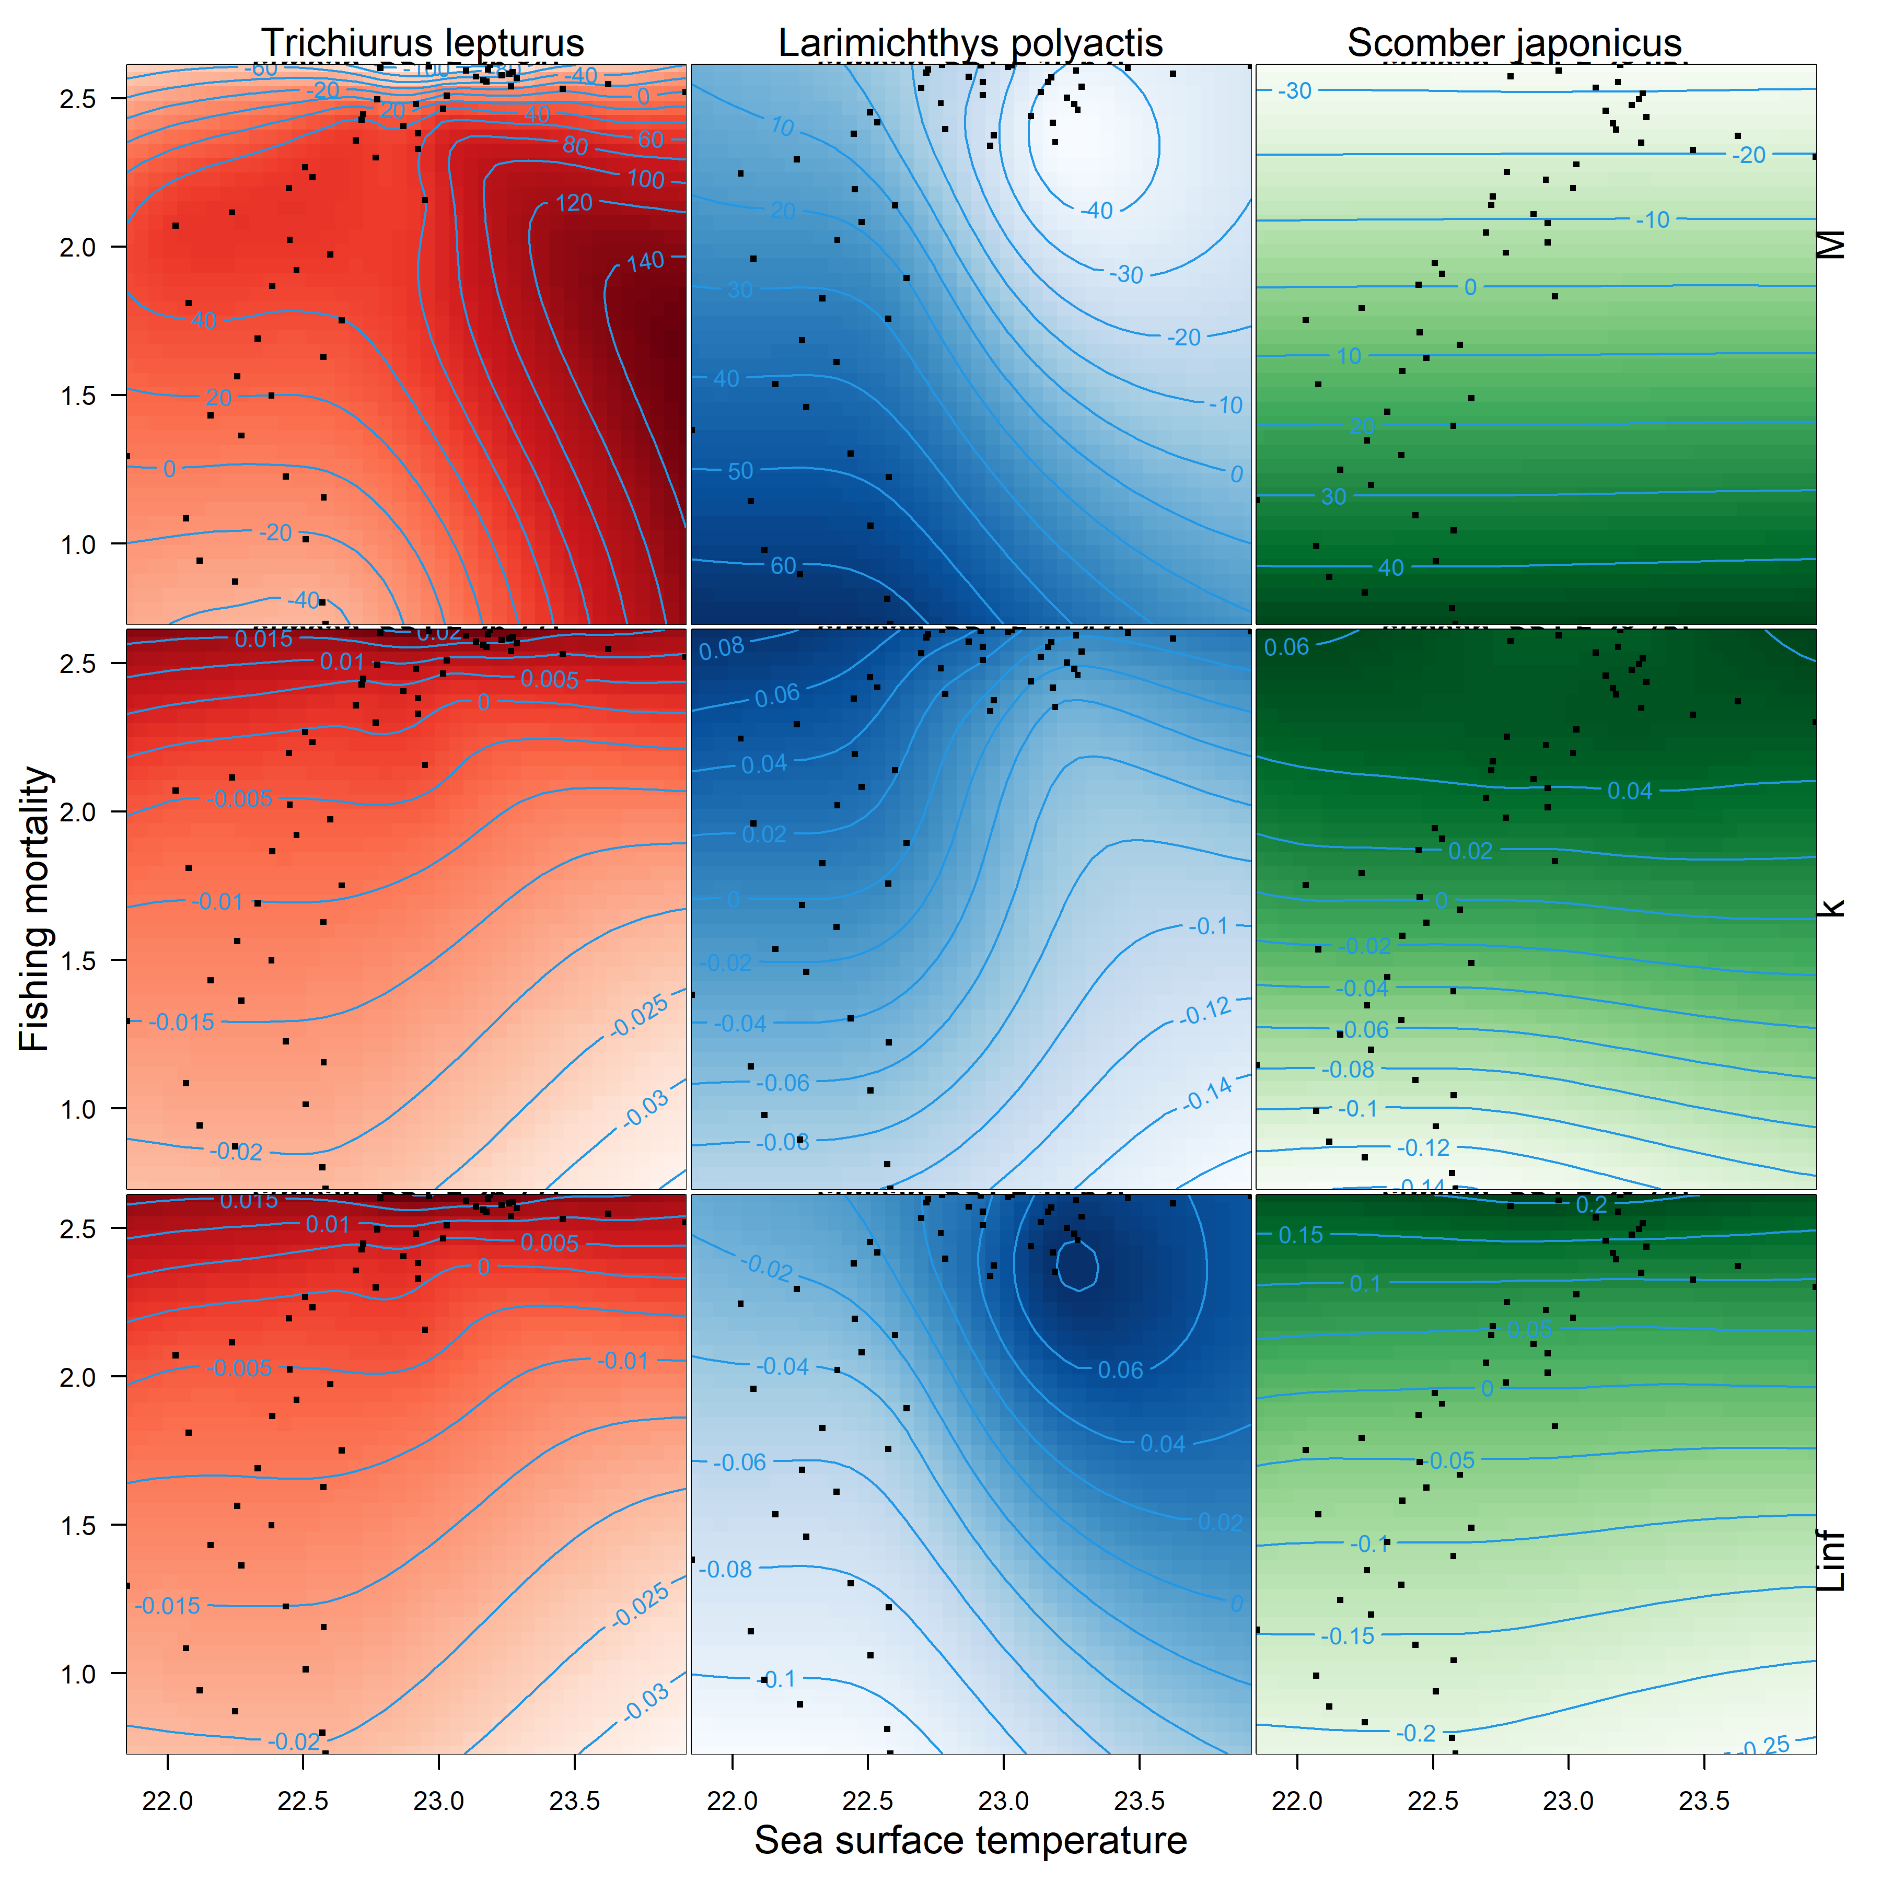

Figure 4. Changes in parameters in relation to sea surface temperature and fishing mortality. Each black dot in a panel represents a year in the trend from figure 2 for a given species and parameter. Contours are developed by a two-dimensional generalized additive model. Colors match the species in other figures. In a given plot, darker shades represent parameter space in which the life history parameters were larger than average; lighter colors are lower than average.